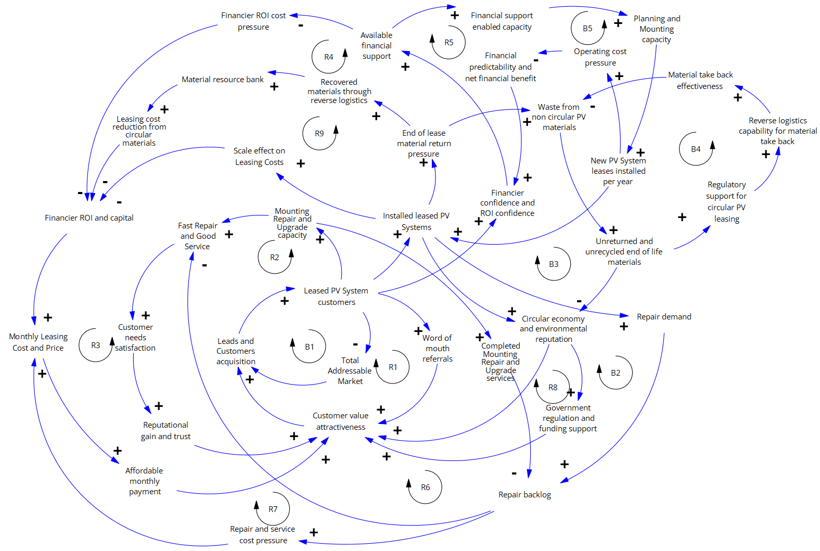

Loop number | Loop name | The causation chain
R1 | Word-of-mouth customer growth | As customer value attractiveness increases, leads and customer acquisition increase. This increases the number of customers with leased PV systems. A larger customer base generates more word-of-mouth referrals. More referrals further increase customer value attractiveness, which drives more customer acquisition.
R2 | Service quality and reputation growth | More leased PV-System customers justify more mounting, repair, and upgrade capacity. Greater capacity improves fast repair and good service. Better service increases customer satisfaction. Higher satisfaction improves reputational gain and trust. A stronger reputation increases customer value attractiveness, which increases leads and customers.
R3 | Scale affordability growth | More leased PV-System customers increase the installed leased PV-System base. A larger installed base improves the scale effect on leasing costs. Lower leasing-cost pressure improves the monthly leasing cost and price position. Better affordability increases customer value attractiveness. Higher attractiveness increases acquisition and further expands the customer base.
R4 | Financing confidence and affordability growth | More leased PV-System customers improve financier confidence and ROI confidence. Higher confidence increases available financial support. Stronger financial support reduces financing-cost pressure and improves the capital-cost position. This supports a more affordable monthly leasing price. Affordability increases customer value attractiveness, which increases acquisition and customer retention.
R5 | Finance-enabled installation growth | More leased PV-System customers increase financier confidence. Higher confidence increases available financial support. Financial support enables greater capacity. More capacity increases planning and mounting capacity. This increases the number of new PV system leases installed per year. More installations increase the installed base of leased PV systems, strengthening the circular economy and environmental reputation. That reputation increases customer value, attractiveness, and customer acquisition.
R6 | Service capacity and backlog recovery | More leased PV-System customers increase mounting, repair, and upgrade capacity. More capacity increases completed mounting, repair, and upgrade services. More completed services reduce the repair backlog. A lower backlog improves fast repair and good service. Better service improves customer satisfaction, reputation, customer value attractiveness, and customer acquisition.
R7 | Repair cost and affordability pressure | A larger installed base of leased PV systems increases repair demand. Higher repair demand increases the repair backlog. A larger backlog increases repair and service cost pressure. Higher service-cost pressure increases the monthly leasing cost and price. Higher price weakens affordability, which reduces customer value attractiveness and slows customer acquisition. This constrains further growth of the customer base and installed base.
R8 | Government support and circular reputation growth | A stronger circular economy and environmental reputation increase government regulation and funding support. More government support increases customer value attractiveness. Higher attractiveness increases customer acquisition. More customers increase the installed base of leased PV systems. A larger installed base strengthens the circular economy and environmental reputation.
R9 | Circular material cost-reduction growth | A larger installed base of leased PV systems increases end-of-lease material return pressure. More returned materials increase the amount of recovered materials through reverse logistics. This builds the material resource bank. A larger material resource bank increases the leasing cost reduction from circular materials. Lower leasing costs improve affordability, customer value attractiveness, customer acquisition, and the installed base.
B1 | Market saturation | More leased PV-System customers reduce the remaining total addressable market. A smaller remaining market reduces leads and customer acquisition. Lower acquisition slows growth in leased PV system customers. This balances the growth process.
B2 | Installed-base service-load constraint | More leased PV-System customers increase the installed base of leased PV-Systems. A larger installed base increases repair demand. Higher repair demand increases the repair backlog. A larger backlog weakens fast repair and good service. Poorer service reduces customer satisfaction, reputation, customer value attractiveness, and acquisition. This slows further customer growth.
B3 | Waste and environmental reputation constraint | A larger installed base of leased PV systems increases end-of-lease material return pressure. If take-back and circular processing are insufficient, waste from non-circular PV materials increases. This increases the amount of unreturned and unrecycled end-of-life materials. More unreturned materials weaken the circular economy and environmental reputation. A weaker reputation reduces customer value attractiveness and slows acquisition.
B4 | Regulatory take-back control | More unreturned and unrecycled end-of-life materials increase regulatory support for circular PV leasing. Stronger regulation increases reverse logistics capability for material take-back. Better reverse logistics improves material take-back effectiveness. Higher take-back effectiveness reduces waste from non-circular PV materials and reduces unreturned end-of-life materials.
B5 | Operating cost and financing constraint | More new PV system leases installed per year increase operating cost pressure. Higher operating cost pressure reduces financial predictability and net financial benefit. Lower financial predictability reduces financier confidence and ROI confidence. Lower confidence reduces available financial support. Reduced support limits capacity and slows new installations.

